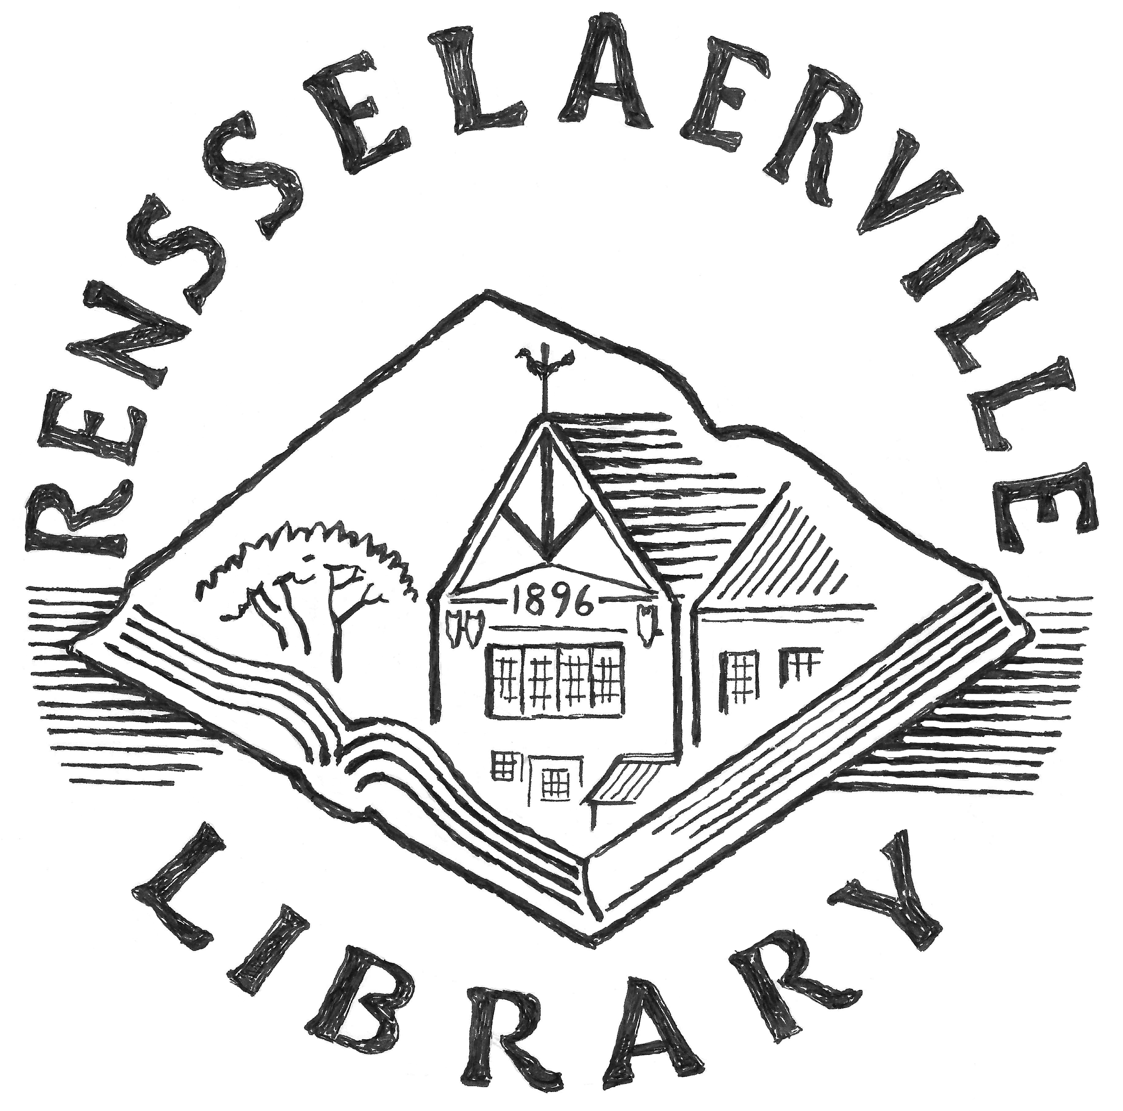PO Box 188
1459 County Route 351
Rensselaerville, NY 12147

Policy Name: | Collection Management
Domain: | External
Applies to: | Library Trustees, Library Director, Staff, Public
Policy Location: | Policy Manual and www.rensselaervillelibrary.org Documents
Date Approved: | October 20, 2009
Date(s) of Revisions:
Legal or Other References:
Notes | Includes: Library Materials Loan Release Form and Reconsideration of Materials Form

Goals
The library's primary responsibility is to assist patrons in their pursuit of information, education, and entertainment, and to inspire and stimulate children's interest in and appreciation of learning and reading. It selects materials in a variety of formats to satisfy the expressed and anticipated interests, tastes, needs, and reading abilities of the diverse community it serves.

Principles of Selection
The library recognizes that its patrons have diverse interests, backgrounds, cultural heritages, social values, political views, and needs. All patrons are free to reject for themselves any materials which do not meet their approval. This freedom does not include the right to restrict the freedom of others to read and inquire.
The library does not exclude or remove materials from its collection on the basis of the author's race, national origin, religious beliefs, sexual orientation, political views, or social values.
As long as materials meet our accepted standards of selection and are deemed to contribute to the goals of the library's collection development, the library does not exclude materials that present extreme points of view; that offer a one-sided representation of opinions, ideas, or events; or that may offend some patrons because of frankness of vocabulary or description.
The library excludes materials that present derogatory stereotypes as valid representations. However, it may include materials that authentically portray a period or way of life characterized by stereotypical thinking and materials that present the prejudices of real or fictional characters. Materials recognized as classics are considered acceptable even if they contain passages that are widely viewed as objectionable by current standards.
The library does not select, retain, or remove materials on the basis of anticipated approval or disapproval of any group of patrons, but solely on the basis of the standards stated in this policy. Library materials will not be marked or identified to show approval or disapproval of their contents. All patrons will have free access to all materials, and no materials will be sequestered (except items that need protection because of rarity, cost, susceptibility to loss, fragility, or unsuitability of format for heavy use).
The library does not restrict the selection of materials because of the possibility that some minors may obtain materials that their parents or guardians consider inappropriate, nor does it deny minors access to any materials in the collection. The library does not stand in loco parentis; if parents or guardians do not want their children to have access to certain library materials or services, it is their responsibility to advise their children. The library has a professional obligation to provide equal access to all library resources for all library users.
The library has adopted and declared that it will adhere to and support the American Library Association's Library Bill of Rights, Free Access to Libraries for Minors, and the Freedom to Read Statement. The content of these documents is understood to be part of this policy.

Standards for Selection
The Library evaluates an item being considered for inclusion in the collection in terms of the following standards. Not all the standards will apply to each item. The evaluation is made with regard to the work as a whole and not necessarily to its individual parts. Each item is evaluated in terms of its own merits, its intended audience, and its relation to the collection.
- Timeliness: current general interest on international, national, and local levels, importance as a document of the times, relevance to contemporary issues
- Permanent value as a standard work
- Suitability of subject, style, format, and content for the intended audience
- Relevance to community needs and interests
- Proven or potential interest or demand
- Reputation, authority, and qualifications of the author, editor, artist-producer, or publisher
- Artistic merit
- Scholarly merit; accuracy and accessibility of content
- Evaluation by staff, local experts, and the public, and by reviewers in professional journals and popular media
- Availability of the subject in the existing collection
- Importance in relation to materials on the same subject in the existing collection
- Importance in relation to existing areas of coverage in order to maintain a well-balanced collection
- Importance in order to provide a wide range of points of view on a subject, including points of view that are unique, alternative, experimental, or controversial
- Availability of the same or similar material in the local area and through the interlibrary loan system
- Cost in relation to the significance of the material according to the above factors

Collection Maintenance
The library maintains the quality of the collection by retaining or replacing essential materials and by removing items that are outdated, damaged or worn out, no longer in demand, or unneeded duplicates. The library does not automatically replace all items that are removed because of loss or damage. Prime considerations in the decision to replace items include the number of duplicate copies needed to meet circulation demand, availability of newer or more authoritative material, presence of similar material in the collection, and community interest. Some older or worn material may be retained, such as classics, one-of-a-kind or irreplaceable items, collectors' items, award-winning children's books, items in the local history collection, items that provide special coverage of a field, and items that are consistently in demand.
Items removed from the collection may be sold, given away, recycled, discarded, or otherwise disposed of at the discretion of the library.
Requests for the Acquisition of Items
Patrons may request that the library acquire specific items. The library will consider the request in terms of whether the items conform to the goals, principles, and standards outlined in this policy; the availability and cost of the items; and the likelihood of general interest in them.

Materials for Temporary Use or Display
The library sometimes accepts collections, works of art, exhibits, and other items for temporary use or display. The library accepts material offered for loan based on the goals, principles, and standards it applies to its permanent collection and its judgment that the material is of current or general interest to its patrons.
The library will make reasonable efforts to preserve and protect borrowed materials, but all items are placed in the library at the lender's own risk. The library assumes no liability for the loss, damage, or theft of any item on loan. The lender may be asked to sign a materials loan release form before the library will accept any item for use or display.
Library Materials Loan Release Form

I hereby lend the following items to the Rensselaerville Library for the period stated. I release the library from responsibility for the loss, damage, or destruction of the items while they are in the possession of the library.

Loan to extend from___________________________ to_______________________________

Items loaned (continue on back of page, if necessary):
________________________________________________________________________________________________________________________________________________________________________________________________________________________________________________________________________________________________________________________________________________________________________________________________________________________________________________________________________________________________________________________________________________________________________________________________________________________________________________

Name of lender________________________________________________________________
Address ______________________________________________________________________
City__________________________________ State______________ Zip__________________
Telephone_____________________________E-mail__________________________________

Signature______________________________________________ Date__________________
Accepted by (Staff)_______________________________________Date__________________
Reconsideration of Library Materials
This policy defends the freedom to read, view, and hear. No material shall be removed from the collection except under the procedure given here.
Patrons who object to the presence of certain materials in the collection and who are unwilling to accept that the inclusion of these materials conforms to the goals, principles, and standards outlined in this policy may submit a Reconsideration of Library Materials form to the library Board of Trustees.
For a reconsideration to be considered, (1) the complainant must be properly identified on the form, (2) the complainant must be a resident of the Library's chartered jurisdiction and hold a valid borrower's card, and (3) the form must be completed in full.
No action shall be taken before the challenge is brought before the board. Challenged material shall not be removed until a final decision is made by the board.
The library will not consider the removal of an item on grounds of obscenity or for any other reason covered by law unless a court of competent jurisdiction has ruled against it. An item will be considered for removal only once in a twelve-month period.
The board will consider the reconsideration at the meeting of the board following the receipt of the form. The board will read and examine the challenged material, consider the specific objections voiced by the complainant, weigh the values and faults of the material as a whole in itself and in relation to the collection, and, if necessary or desired, solicit advice and opinion from other library directors and boards, the Upper-Hudson Library System, the American Library Association Office for Intellectual Freedom, and the New York State Intellectual Freedom Committee. The board will issue a written report within ninety days of the receipt of the challenge containing its decision and recommended action regarding the challenged material.
Reconsideration of Materials in the Rensselaerville Library

Date____________________________________________

Name of complainant___________________________________________________________
Address ______________________________________________________________________
City________________________________________State________ Zip code______________
Phone number______________________Email Address______________________________ Rensselaerville Library card number_________________________________

Are you making this challenge as an individual ?____ (check here if yes)
Or as the representative of an organization? ____ (check here if yes)

If you are speaking on behalf of an organization, give the name and address of the organization: ____________________________________________________________________________________________________________________________________________________________

Type of item you are challenging (fill out a separate form for each item challenged):
Book____ Audio____ Video____ Magazine____ Newspaper____ Computer program____ Other________________

Title of item__________________________________________________________________________
Author _______________________________________________________________________
Publisher/Distributor/Producer __________________________________________________
Date of publication _____________________________________________________________
What brought this item to your attention? _________________________________________
Is your objection to this item based upon your own exposure and reaction to it, upon complaints about it made directly to you by others, or upon reports you have heard about?
______________________________________________________________________________
Have you read, viewed, or listened to this item in its entirety? If not, what portions of it have you read, viewed, or listened to? (List portions by page number, time into tape, or other identification.) ____________________________________________________________________________________________________________________________________________________________
To what specific aspects of the item do you object? Cite specific pages, passages, or scenes. Can you suggest any materials to provide additional information or other viewpoints on this topic? (Use back of page and additional page, if necessary.)
______________________________________________________________________________ ______________________________________________________________________________

Signature_______________________________________________Date__________________

Accepted by (Staff)_______________________________________Date__________________

Authorizing Signatures
Chairman, Board of Trustees _________________________________________ Date __________
Director __________________________________________________________ Date __________

Additional Notes:

